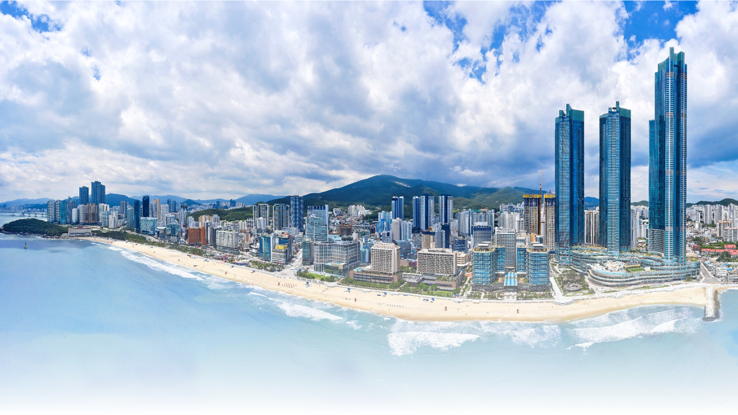
www.atsc2025.org

ATSC 2025
The 14th Asian Thermal Spray Conference & Expo

Exhibition & Sponsorship Prospectus

- Greetings ------------------------------------------------------- 2
- General Information ------------------------------------------------ 3
- Exhibition Information ------------------------------------------ 4
- Sponsorship Information ---------------------------------------------- 5
- Terms & Conditions ----------------------------------------------- 9
- Application Form --------------------------------------------- 10

- Greetings

The Asian Thermal Spray Conference (ATSC) is the foremost biennial event in the Asia–Pacific region, dedicated to the science, technology, and application of thermal spray coatings. Since its inception, ATSC has served as a vital platform for idea exchange, innovation promotion, and collaboration among academic researchers, industrial engineers, manufacturers, and end users across countries including Japan, Korea, China, Singapore, India, Australia, and beyond.
In 2025, ATSC proudly celebrates its 20th Anniversary, marking two decades of leadership in thermal spray science and engineering. This commemorative edition “ATSC 2025” will be hosted in the dynamic port city of Busan, Korea, from November 17 to 19, 2025, at the Busan Port Exhibition & Convention Center (BPEX).
Previous ATSC events held across Asia Pacific including Japan, Korea, China, Singapore, India, and Australia—have garnered global acclaim for their academic rigor and industrial relevance. The 14th ATSC in Busan will build on this legacy, combining Korea’s excellence in materials science with its renowned hospitality and rich cultural heritage.
Through this conference & Expo, we hope to establish a proactive business platform where international researchers attending the conference can engage with domestic companies specializing in eco-friendly electronic materials and nanotechnology.
We cordially invite you to join this landmark edition of ATSC and celebrate two decades of innovation and collaboration in the field of thermal spray.
See you in Busan!

- General Information

(1) Title
ATSC 2025
(The 14th Asian Thermal Spray Conference & Expo)

(2) Date
17(Monday) – 19 (Wednesday) November, 2025

(3) Venue
BPEX(Busan Port International Exhibition & Convention Center), Busan, Korea

(4) Hosted by
Korean Thermal Spray Association

(5) Organized by
ATSC 2025 Organizing Committee

(6) Expected Number of Attendees
Approximately 300 delegates from worldwide

(7) Contacts
ATSC 2025 Secretariat

Tel. +82-42-489-7070
E-mail. secretariat@atsc2025.org
Address. #804-1, 8F, 303, Bugyuseong-daero, Yuseong-gu, Daejeon, Republic of Korea

- Exhibition Information

(1) Schedule
Exhibition Plan | Date | Time (KST)
Booths Decoration | 16 (Sun.) Nov. 2025 | 17:00 ~ 21:00
Exhibition | 17 (Mon.)~18(Tue.) Nov. 2025 | 10:00 ~ 17:00
Exhibition | 19 (Wed.) Nov. 2025 | 10:00 ~ 15:00
Booths Dismantling | 19 (Wed.) Nov. 2025 | 15:00 ~ 17:00

(2) Place: Lobby of Event Hall, 5F, BPEX, Busan, Korea

(3) Application Due Date: 17(Friday) October, 2025

(4) Exhibition fees: KRW 2,500,000(USD 2,000) / Per booth

(5) Benefits of Exhibitor (Per a booth)
- 1 conference registrations
- Logo and web link on the ATSC 2025 Official Website
- Directory on the ATSC 2025 Program book

(6) Standard Booth
Booth Package (Standard Booth)
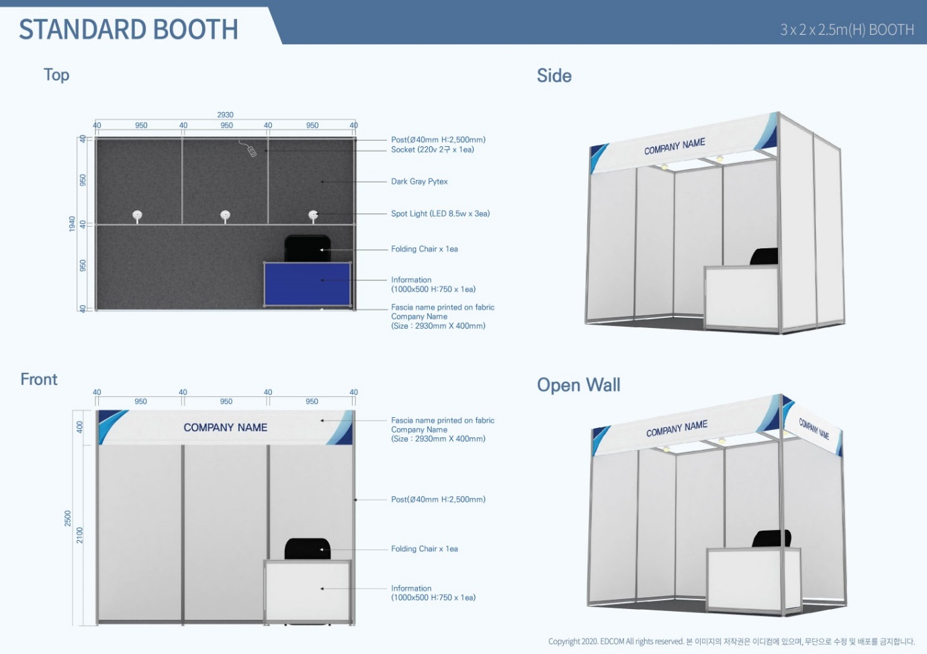 | - The booth of Octanorm  - Area: 3 m Width X 2 m Length X 2.5 m Height  - Gray carpet, 2mm  - Banner (Company name & logo)  - An information desk with a folding chair  - Electric Outlet: 1 spots with 2 sockets / 220V

(7) Other Instructions
No. | Process | Dates
1 | Distribution of Exhibitor’s prospectus | -
2 | Deadline for Exhibition Application | 17 October, 2025
3 | Directory contents on Program book | 24 October, 2025
4 | Additional Items Application | 24 October, 2025
5 | Notification of Final Booth Layout | 31 October, 2025

(8) How to be an exhibitor & sponsor
Application Form | Please return the filled-out Application Form via email to the ATSC 2025 Secretariat at secretariat@atsc2025.org .
Payment | Please settle payment by wire transfer and send a copy of the remittance receipt via email to the Secretariat for smooth processing.
Cancelation | Cancelation of exhibition space must be sent in writing to the Secretariat via e-mail no later than 24 October 2025. Refunds will be made after conference.

- Sponsorship Information

 | CO-ORGANIZER | PLATINUM | GOLD | SILVER
 | $5,000  ￦5,000,000 | $5,000  ￦5,000,000 | $3,000  ￦3,000,000 | $2,000  ￦2,000,000
Free Registration | - | 2 | 1 | -
Company's Advertising Film  at the Banquet | ✽ | - | - | -
Program Book :  Advertisement 1P | 1st Priority |  | 2nd Priority | 3rd Priority
Logo on Souvenir if any | - | ✽ | - | -
Projection of Logo in the Session Room during Intermission | ✽ | ✽ | ✽ | -
Company Description  on Website | ✽ | ✽ | ✽ | ✽
Logo on Website Main Page | ✽ | ✽ | ✽ | -
Logo on Banner | ✽ | ✽ | ✽ | ✽
Logo on E-newsletter | ✽ | ✽ | ✽ | -
Insertion of Company Leaflet in Conference Kit | ✽ | ✽ | - | -

- Terms & Conditions
1. TERMS OF REFERENCES  In these Terms and Regulations for Exhibitors,  a. The term `Exhibitor' shall include all employees, personnel and agents of any organization, partnership, firm or individual to who has been allocated for the purpose of exhibiting and sponsoring.  b. The term ‘Exhibition’ shall mean the Exhibition of the ATSC2025.  c. The term ‘Sponsor’ shall mean the sponsor of the ATSC2025.  d. The term 'Organizer' shall mean the Organizing Committee of the ATSC2025.  2. APPLICATION FOR PARTICIPATION  a. All applications for participation shall be made on the enclosed application form, which shall be submitted to the organizer or its representatives.  b. The contract shall be established when the exhibitor or sponsor submits the application form.  3. ALLOCATION OF EXHIBIT SPACE  a. The organizer shall allocate space in accordance with the nature of the exhibits or in the manner the organizer deems fit.  b. The organizer shall reserve the right to change the space allotment for the exhibitor at any time prior to the build-up of the exhibition. If any exceptional circumstances demand, such changes shall be at the discretion of the organizer and the exhibitor shall have no claim for compensation as a result of the changes.  4. USE OF EXHIBIT SPACE  a. Exhibitors are bound to exhibit the announced products and to manage the exhibits with competent personnel during the open hours of the exhibition.  b. All exhibits must accord with the description on the application form, and be related to the theme of the exhibition. Direct sales without permission of the organizer are prohibited. If the exhibitor violates the above-mentioned rules, the organizer can have a right to stop the exhibition and to remove the exhibits from the booth.  c. Exhibitors may not sublet the space allotted to them to third parties either wholly or in part without the written consent of the organizer.  d. Modifications including decoration such as painting the floor, ceiling and pillars, will not be permitted, and the exhibitor shall compensate for any consequent damages to the exhibition.  5. TERMS OF PAYMENT  a. Exhibitors must pay participation fee and/or relevant booth charges at the time of the application. The participation fee shall be paid by no later than 24 October 2025.  b. The exhibition participation fee shall be paid by the due date. Otherwise the organizer has the right to cancel the contract. All refund and cancellation shall be proceeded by following Term No. 6 “BREAK OF CONTRACT AND WITHDRAWAL BY EXHIBITOR”  6. BREAK OF CONTRACT AND WITHDRAWAL BY EXHIBITOR  a. In the event of abandonment or rejection of all the allocated space, the organizer has the right to cancel the exhibitor's application. In this case, the exhibition fee will not be refunded.  b. In the event of partial abandonment or rejection of the allocated space, the organizer has the right to cancel the application and reallocate the partly abandoned or rejected space. In this case, if the participation fee for the diminished space is already paid, half of the fee will be refunded. But if that fee is not yet paid, the exhibitor should pay half of the fee applicable to the diminished space. | c. The exhibitor can terminate this contract by writing notes to the Local Organizing Committee via email, fax or post and is effective the day of receipt on the following criteria:  c -1. Cancellation before 24 October 2025 shall forfeit 20% of the total booth(s) fee.  c -2. Cancellation after 24 October 2025 shall forfeit 100% of the total booth(s) fee.  c -3. If the exhibitor “no show”, the rental or booth(s) fee shall not be refund. the Local Organizing Committee has the right to use “no show” exhibition booth(s) in the exhibition’s best interest. Failure to occupy booth(s) or exhibit space shall not release the exhibitor from obligation paying in full of the fee.  7. CHANGES  The organizer reserves the right to change the venue and duration of the exhibition if exceptional circumstances demand. In the event of a change of venue and/or cancellation of date of the exhibition, half of the exhibition deposit will be refunded to the exhibitors. But when the events are caused by the following causes: strike, lockout, injunction, emergency, act of God, act of war or any other cause beyond control of the Exhibit Management, the deposit will not be refunded.  8. CONSTRUCTION AND DECORATION OF STAND  All exhibitors must complete their construction and/or decoration by the date and time stipulated by the organizer.  9. REMOVAL OF EXHIBITS  Exhibitors shall remove all exhibits from the exhibition hall within the period stipulated by the organizer and shall indemnify the Organizer against any loss by reason of delay or damage to the exhibition hall.  10. SECURITY AND INSURANCE  a. The organizer shall take all reasonable security precautions in the interests of exhibitors and visitors.  b. The organizer shall not be held responsible for any loss or theft of or damage to exhibits at the exhibition hall during the build-up, exhibition and dismantling periods.  c. The organizer shall not be held responsible for any loss of or damage to exhibits or articles belonging to the exhibitor. Exhibitors are responsible for acquiring all the necessary insurance policies.  11. FIRE REGULATIONS  a. Materials used in booth and display construction must be properly fireproofed in accordance with regulations of the Organizing Committee.  b. The organizer has the right, should circumstances necessitate, making changes in the exhibitor's booth in the interest of the control of exhibits.  12. SUPPLEMENTARY CLAUSES  a. Whenever necessary, the organizer shall have the right to issue supplementary regulation in addition to those in the Terms and Regulations for Exhibitors to ensure the smooth management of the exhibition.  b. Any additional written regulatory instruction shall form part of the Terms and Regulations for Exhibitors and they shall be binding on the exhibitions.

VI-I. Exhibition Application Form

Please fill up this form and send it to the Secretariat of ATSC2025 via e-mail by 17 October 2025.
※ Secretariat of ATSC 2025
#804-1, 8F, 303, Bugyuseong-daero, Yuseong-gu, Daejeon, Republic of Korea
Tel. +82-42-489-7070 / E-mail. secretariat@atsc2025.org

- Organization Information
■ Organization Name
■ Contact Person
■ Department
■ Address
■ Zip Code |  |  | ■ Country
■ Telephone |  | ■ Mobile
■ E-mail |  | ■ Fax

- Exhibition Details
Please check the number of booths you apply
Number of Booth(s)
□ 1 Booth | □ 2 Booths | □ 3 Booths | □ _________

3. Payment Method (Bank Transfer only)
Account Holder: Korean Thermal Spray Association (한국용사기술협의회)
Account Number: 249-890009-05704
Bank Address: KEB Hana Bank
Bank Name: 513, Yeongdong-daero, Gangnam-gu, Seoul, Republic of Korea
SWIFT Code: KOEXKRSE

I hereby confirm that I have read and understood the Information of the prospectus and terms of ATSC 2025.
Also, I write signature on behalf of my affiliation to participate ATSC 2025 as supporting document of application.

Date : _______________________________ Signature : ____________________________

VI-II. Sponsorship Application Form

Please fill up this form and send it to the Secretariat of ATSC 2025 via e-mail by 17 October 2025.
※ Secretariat of ATSC 2025
#804-1, 8F, 303, Bugyuseong-daero, Yuseong-gu, Daejeon, Republic of Korea
Tel. +82-42-489-7070 / Fax. +82-42-822-7073 / E-mail. secretariat@atsc2025.org

1. Organization Information
■ Organization Name
■ Contact Person
■ Department
■ Address
■ Zip Code |  |  | ■ Country
■ Telephone |  | ■ Mobile
■ E-mail |  | ■ Fax

2. Sponsorship Details
Please check the number of booths you apply
Categories of Sponsorship
□ Co-organizer | □ Platinum | □ Gold | □ Silver

3. Payment Method (Bank Transfer only)
Account Holder: Korean Thermal Spray Association (한국용사기술협의회)
Account Number: 249-890009-05704
Bank Address: KEB Hana Bank
Bank Name: 513, Yeongdong-daero, Gangnam-gu, Seoul, Republic of Korea
SWIFT Code: KOEXKRSE

I hereby confirm that I have read and understood the Information of the prospectus and terms of ATSC 2025.
Also, I write signature on behalf of my affiliation to participate ATSC 2025 as supporting document of application.

Date : _______________________________ Signature : ____________________________

